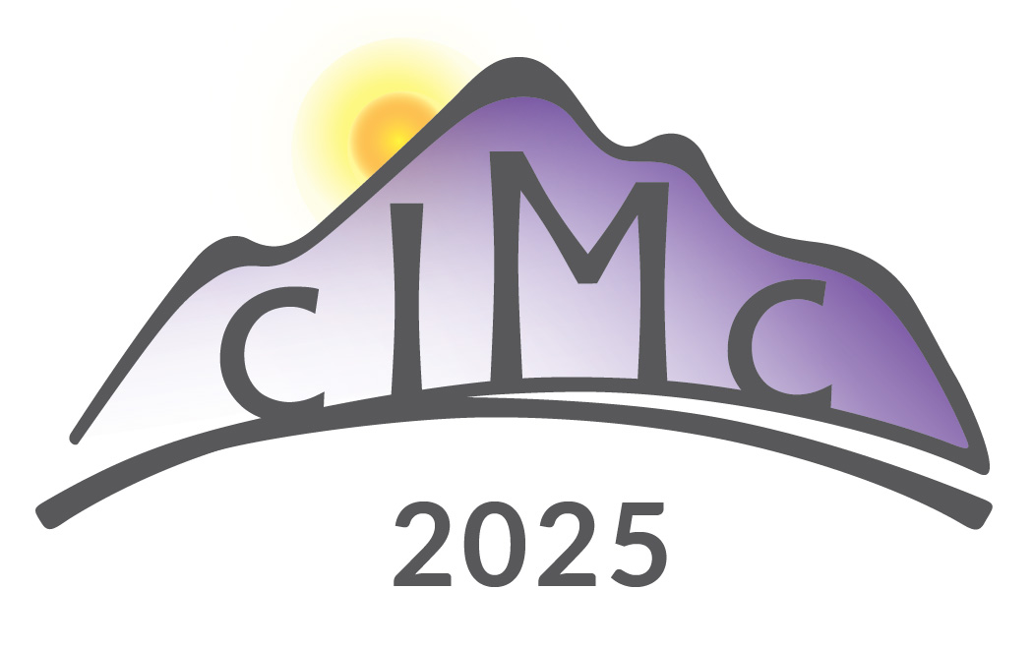

**Sponsorship Application**

**Colorado Integrative Medicine Conference**

(cIMc 2025): Focus on Personalized Mind-Body Medicine for Aging Well

July 11-13, 2025

YMCA of the Rockies, Estes Park, CO

Company Name____________________________ Contact Name____________________ Mailing address_________________________________________________________________ City_____________ State/Province_____________ Country______ ZIP/postal Code_____ Phone________________________________ Fax______________________________________ E-mail________________________________ Web site__________________________________

Please select the level that you would like to sponsor and any add-ons you wish to include:

___ Presenting Sponsor: $30,000 ___ Silver Sponsor: $10,000

___ Diamond Sponsor: $20,000 ___ Bronze Sponsor: $5,000

___ Gold Sponsor: $15,000

**Add-ons:**

___ Full Page Ad: $20,000 ___ Branded Fitness Room: $10,000

___ Half Page Ad: $10,000 ___ Branded Wellness Room: $10,000

___ Quarter Page Ad: $5,000 ___ Branded Health Snack Station: $10,000

___ Sponsored Speaker Talk: $5,000 ___ Branded H2O Bottles: $10,000

___ Branded Photo Booth: $5,000 ___ Branded Networking Event: $20,000

___ Branded Item in Tote Bag: $3,000

If credit card, Name of Card Holder _____________________________________________ Credit Card Number______________________________________ Exp Date_____________ 3-digit code on the back ________ Zip Code for credit card_______________ Authorized Charge Amount___________

Signature Authorization__________________________________ Date__________________

**For sponsor application submitted before June 2025:**

**Payment by check (preferred, please check this box) ____If paying by check, please send your payment and application to InspiredIM, 1342 Jayhawk Dr. Suite 200, Fort Collins, CO 80524.**

**OR please provide your company’s email for Paypal invoice from InspiredIM:_______________________ (must pay upon the receipt of Inspired IM’s invoice. Your sponsorship is recognized only after payment is received.**

**For sponsorship applications received in July of 2025, please provide your Credit Card (Visa or MC only, no American Express please). Please state the type of Credit Card__________**

**Please sign that you have read this agreement and have the authority to sign this application on behalf of your company. Thank you for your support. We wish you great business success and networking!**

**Signature:____________________________________________ Date____________________________________**

Questions - Email: sponsor[@inspiredim.org](mailto:info@inspiredim.org) Phone: (970) 310-3030

https://www.InspiredIM.org/conferences/ to book lodging and register for additional conference attendees. It will be a productive and fun conference! We look forward to working with you to advance evidence-based integrative healthcare and education for human wellness!

InspiredIM is recognized by the Internal Revenue Service (IRS) as a 501(c)(3) nonprofit organization. Tax ID: 56-2588132. Sponsorships are tax deductible in the United States as charitable contributions to the maximum extent provided by law.